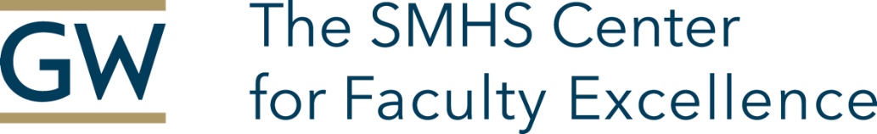

Application for the SMHS Scholarly Writing Program
Due December 29th, 2023

Name: Department: Division:
Academic Rank:
Email:
Cell Phone:

Applicant’s Commitment

If selected, I will commit to meeting with my peer group/coach on a schedule determined by the group/coach. During the 6-month program, I commit to carefully reading and reviewing other group members’ articles & providing constructive feedback, spending time revising and refining my article, and completing assigned learning activities to maximize my skills in writing.
I understand that I will need to account for my time spent writing and to meet set writing deadlines for my article with drafts of these writings to be posted on a members-only website.

Signature: ________________________________ Date: _______

Chair/Division Chief/Supervisor’s Commitment

I support this applicant’s participation in this program:

Printed Name: ____________________

Electronic Signature: ___________________________

Date: __________________

Submit this completed document and the following items in one PDF using this naming convention, Last Name/First Initial/Date of Submission:
  - Curriculum vitae/résumé/or list of publications
  - Written statement- please provide a 250–500-word explanation as to why you would like to be considered for this program. Include a self-assessment of your writing strengths and opportunities for improvement.
  - Draft of the article Abstract you will be writing during the program and submitting at program completion. The abstract should be less than 500 words. You must attest that the work described in the Abstract includes all of the data and interpretations that form the basis of the article you will be working on during the program. If the work required IRB approval that information should be provided in the abstract.

